All Stars and Dynamos Cricket - Club Marketing Strategy - Updated November 2019

Introduction
This plan is designed to assist you in promoting your cricket club and the All Stars and Dynamos Cricket programmes in your local area. The ideas below are a guide and not an exhaustive list. The plan is designed to maximise the visibility of your club and programme locally, and runs alongside the wider reach promotion of All Stars and Dynamos Cricket from ECB in a national capacity, and LCF at county wide level.
This guide includes ideas for your club, and provides information about what promotion will be done by both the ECB and the LCF, focussing on the following areas:

School Engagement
Local Community Marketing
Social Media
Rainbows/Brownies/Beavers/Scouts
Media and Press
Marketing & Promotional Activity Tracker

When trying to promote the All Stars and Dynamos Cricket brands it is important to consider the following strategy to get the best out of your promotion and marketing. Asking the following questions may help to shape your plan.
Why? Why are you promoting? (Increase participation on programme, targeting specific events surrounding the programme, boosting publicity, reaching a wider target audience)
What? What are you going to market/ promote? (Details of sessions, success stories, promo events)
How? How are you going to go about it? (Social media channels, website, posters in your local community, taster sessions, club events)
Who? Along with our current cricket networks we are looking at a total new audience, which we don’t currently engage. Mums & dads, and trying to excite kids into choosing cricket as a great sport for the whole family to enjoy.

School Engagement
The role of the LCF
The LCF including the Cricket Development Coaches (CDC’s), will deliver engagement activities to at least two primary schools in your area. This engagement activity is an assembly or taster session linked to All Stars and Dynamos cricket, and will be specifically targeted at Key Stage One.
Your club will be notified when this engagement activity will take place.
What your club can do
Whilst our CDC’s will be going into your agreed local schools on your behalf, we would encourage you to be in attendance when they are delivering these engagement sessions, and to also promote All Stars and Dynamos cricket to any other nearby schools. You can do this in a number of ways including:
- Assembly visit (delivered by either the club or the school on behalf of the club)
- Coaching sessions
- Hosting events at the club (Kwik Cricket festivals etc)
- Create relationships with schools/teachers to encourage them to assist with the promotion of All Stars and Dynamos Cricket
- Hand out flyers/Talk to parents before or after school
- Promoting your programmes in the school newsletter

Local Community Marketing
Each club is, through the ClubSpark website, provided with All Stars and Dynamos Cricket branded promotional material. This can be used on social media, and for advertising such as posters and leaflets for distribution to your local area.
These can be found under ‘Resources’ located in the top right of the home screen.
What your club can do
There are many places within your local community in which you might be able to promote your club and All Stars and Dynamos Cricket through flyers and posters and linking via social media. These include:
- Local shops, businesses and any major supermarkets (include any club sponsors)
- Leisure centres, including any day centres or children’s centres
- Village hall or community centre
- Medical centre
- Local Press/local radio
- Other local sports clubs/teams

Social Media
The role of the ECB/LCF
The ECB will be involved in a huge national campaign across a variety of social media including:
- Facebook, Twitter, Instagram, YouTube
  - Posting images and clips of the programme
  - Using targeted advertising to ensure posts are visible to parents and young families online
  - An England player campaign
The LCF, as well as accessing the marketing done by the ECB, will be:
- Getting the All Stars and Dynamos Cricket brand out across the existing LCF networks and to cricketing contacts across the county
- Promoting All Stars and Dynamos Cricket centres more regionally using local social media contacts, local press, schools and community groups
- LCF/LCCC campaign using Lanky, Twinkle and the stars of Lancashire County Cricket Club
What your club can do
Social media offers a number of ways to promote your own club, some of the methods we feel have worked best by clubs over the past 3 years are listed below:
- Initially use ECB and LCF media to help build awareness of All Stars and Dynamos Cricket
  - Retweet, share, or quote appropriate media mentioning that your club will be taking part. Posts with images and video work best at grabbing people’s attention
- Put your own posts out about All Stars and Dynamos Cricket with specific reference to your own club (what day/time it is on and when it is starting)
  - Encourage others within your club to share/retweet, specifically people with young families
  - Tag in local press, schools or community groups and ask them to share
- Hype up positives about the programme
  - Mention the All Stars and Dynamos Cricket specific kit included for children
  - Post when you get sign-ups
  - Mention the taglines of the campaign – encourage parents to come down to join in with their children
  - Post more frequently as the start date approaches, enthusing about getting started but mentioning the limited time left to sign up
  - If you are offering “Week 0” free taster sessions or encouraging signups to “bring-a-friend” beforehand promote this and make sure you have the capability for parents to sign up there
- Other best practice ideas that have worked for clubs are:
  - Set up a Facebook event for your All Stars and Dynamos Cricket – by setting this to public it will be visible to anyone in your area and the more people signing up and attending will publicise it further
  - Use #allstarscricket, #bigmoments, #LCFAllStars on twitter to engage with a larger audience
  - Make use of the direct-link option within ClubSpark, and share it to send parents straight to your club’s programme
  - Consider boosting your post on Facebook or using Twitter ads to reach a larger audience. Although this might be an initial outlay, it will get your posts out to a lot of people and as little as 2 extra sign-ups could recoup this cost ( More information on how to do this is at the end of this guide)

Five Top Tips for promoting your clubs All Stars and Dynamos Cricket Programme on Social Media

- Links – Include your vanity URL. A call to action directs users towards what you want them to do
You can find your vanity URL on your clubspark page

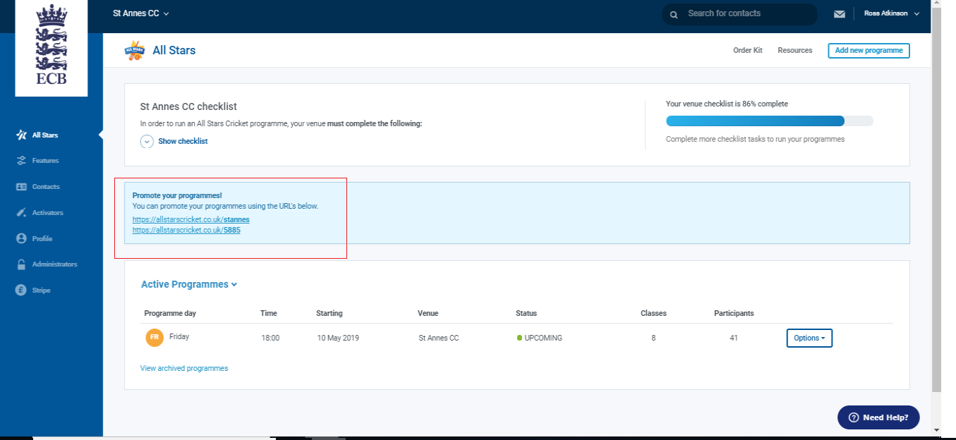

- Media – Be sure to include at least one photo (or video) with every post

All Stars Images can be found at the link below
https://www.ecb.co.uk/be-involved/club-support/marketing-material/all-stars-cricket

- Timing of Posts & Consistent Activity – The two most active windows for social media users are 07:00 – 09:00 & 19:00 – 21:00. As well as considering the time of day that you post, make sure you are consistently active on social media in the lead up to your All Stars and Dynamos Cricket programmes

- Emoji’s – Use emoji’s to give your posts personality. The programme is meant to be ‘fun’ after all!

5. Hashtags (Twitter/Instagram) & Tags – Hashtags are very useful if used correctly, as they will help users viewing content relating to those trending topics/keywords find your content. Some examples of hashtags you might use for All Stars and Dynamos Cricket Cricket; #BigMoments #AllStarsCricket #FridayFeeling (if your centre is being run on a Friday), #Parenting, #Cheshire, or area specific (e.g. #Stockport). Take the opportunity to tag in other accounts where possible. On Twitter - this doesn’t have to be in the body of text, as you only have 280 characters. You can also tag accounts in the photos you post

Example All Stars posts (copy & paste to your feeds – add your own photos/hashtags/tags)

⭐ | Who’s ready for @allstarscricket at ENTER CLUB NAME? Register your 5-8-year-old for our eight-week cricket programme using the following link; ENTER VANITY URL #BigMoments

⭐ | There’s still time to register your 5-8-year-old on our eight-week @allstarscricket programme, starting on ENTER START DATE. Click the following link to book your place; ENTER VANITY URL #BigMoments

⭐ | Eight weeks’ worth of #BigMoments are about to commence at ENTER CLUB NAME. Get your cap, shirt, backpack & bat, and join us on ENTER START DATE. Click the following link to confirm your place; ENTER VANITY URL

⭐ | Register for @allstarscricket at ENTER CLUB NAME and not only will you receive eight weeks of coaching from our trained Activators, you’ll also receive;
✳️ Your own personalised All Stars shirt 👕
✳️ An All Stars kitbag including your own bat & ball! 🏏
✳️ All Stars Activity Book, including stickers! 📘
🔗 ENTER VANITY URL
Rainbows/Brownies/Beavers/Scouts
When thinking about promoting All Stars and Dynamos Cricket to local community groups, a very good opportunity to do this is through Rainbows, Brownies, Beavers and Scouts groups. There are over 450,000 children and young children participating in Scouts and Guides in the UK, with most communities having a group close by. Rainbows/Beavers/Brownies/Scouts runs for children age six to eleven and this is the perfect target audience for All Stars and Dynamos Cricket.
What your club can do
The whole ethos of Scouts fits well with the benefits being promoted within the All Stars and Dynamos Cricket products, but a challenge may be making cricket seem as exciting and adventurous as other activities that they are involved in such as kayaking and abseiling. However, we are offering a sporting activity at a different time to Beavers and with complementary benefits. For example every young person in Scouting enjoys a balanced range of activities, events and experiences, and we can promote All Stars and Dynamos Cricket as part of this balance.
In recognising that Rainbows/Beavers/Beavers/Scouts could potentially be a good source of All Stars and Dynamos Cricket participants, as an All Stars and/or Dynamos Cricket Centre you should engage with your local groups and specifically the Rainbows/Beavers section.
To find your local Group, go to: http://scouts.org.uk/home or https://www.girlguiding.org.uk/what-we-do/rainbows-5-7/im-a-rainbow/
What to do when you have found your local Rainbows/Beavers/Brownies/Scouts group:
- Ring the contact and explain requirements
- Email All Stars and Dynamos Cricket resources and information
- Visit a group session
- Do an ‘assembly-like’ event if appropriate
- Run an All Stars and Dynamos Cricket taster session before your programme start date
- Take flyers to hand out
- Tag group on Twitter feed and Facebook

Media and Press
The role of the ECB/LCF
The ECB will be sending out national press releases covering the All Stars and Dynamos Cricket programmes with country wide messages and promotions. They will also be running a series of promotions over local radio stations during the school run.
The LCF will using the ECB press releases, and cascading these through existing networks and to cricketing contacts across the county, including regional press. We are also planning to deliver some promotional material of All Stars and Dynamos Cricket over local radio, through editorial pieces and competitions.
What your club can do
Contact your local press with your own information about what is happening, mentioning All Stars and Dynamos Cricket is a brand new national initiative. Be simple and direct regarding what is taking place, where is it happening, what context and what impact it will have in your community. Items should be digital, editorial or story-based, and easily transferable into a newspaper insert.
When you are putting out informative pieces about All Stars and Dynamos Cricket think about mentioning the following:
- The age groups and where kit is included and delivered to children
- Offer ‘golden tickets’ as competition prizes
- Mention the taglines of the campaign – magic moments, fun, safe environment, FUNdamental movement skills, healthy active kids, and that parents are being actively encouraged to come down to join in with their children
- Reference to local sponsors
- Use quotes from All Stars and Dynamos Cricket ambassadors and ECB press releases
- Target early stage i.e. pre May and late stage i.e. 2 weeks before your programme start approaches, enthusing about getting started but mentioning the limited time left to sign up with reference to how to register
- If you are offering “week 0” free taster and bring-a-friend sessions beforehand promote this and make sure you have the chance for parents to sign up at the club/session
- Emphasise the community ethos and impact
- Highlight the collaboration with local schools and maybe use a school picture

Marketing & Promotional Activity Tracker
Please use this to keep track of your local community activation. Tick off each line on your checklist with each successful club led marketing & promotional activity. Please also use the space on each box, to plan and list more details of your planned activity
Marketing & Promotional Activity | Tick
- We know which schools the LCF are delivering in and when:

- We have contacted additional schools in local area to arrange All Stars and Dynamos Cricket promotional visits:
- We are running a taster event for the local schools at our club:
- We have placed posters in:

- We have created a link with local grassroots sports clubs:
- We have published engaging content on our FB & Twitter pages:
- We have targeted local Beavers & Rainbows group, to deliver All Stars and/or Dynamos Cricket taster sessions:
- We have contacted our local press, to tell them about our All Stars and Dynamos Cricket Programmes:

Guide to Promoted (boosted) Facebook posts
Step 1: On your club Facebook page write a post about your All Stars and Dynamos Cricket programmes, including your own unique booking link and some images. (example posts and how to find your booking link are in the social media section of this guide)

Step 2: Post this on your Facebook page.

Step 3: Once it’s live, hit the 'Boost Post' button under the post.

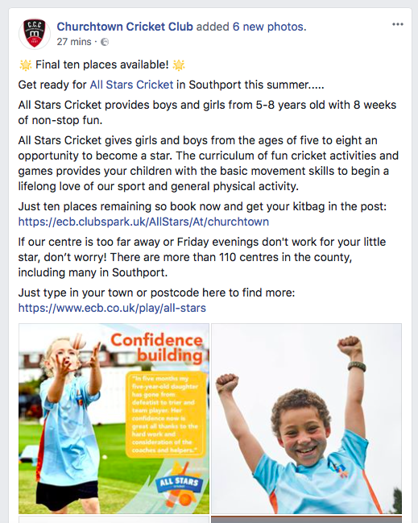
Step 4: Target your campaign - location, target age group (parents of 5-8 and 8-11 years old), you can add interests etc.
Note: in ‘interests’ you can add a pre-set target audience. There is one called ‘mothers with children aged 5-11’ ideal for All Stars and Dynamos Cricket!!

Step 5: Set budget for campaign and timescale (eg seven day campaign, ending three weeks before first session). Facebook will calculate an estimated audience you will reach.

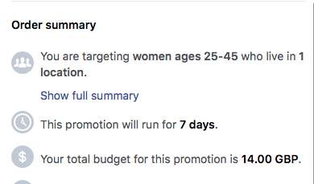
Step 6: Monitor your campaign on the button under the post as it's live. Organic is the page followers you reach, paid is directly from the paid promotion.

